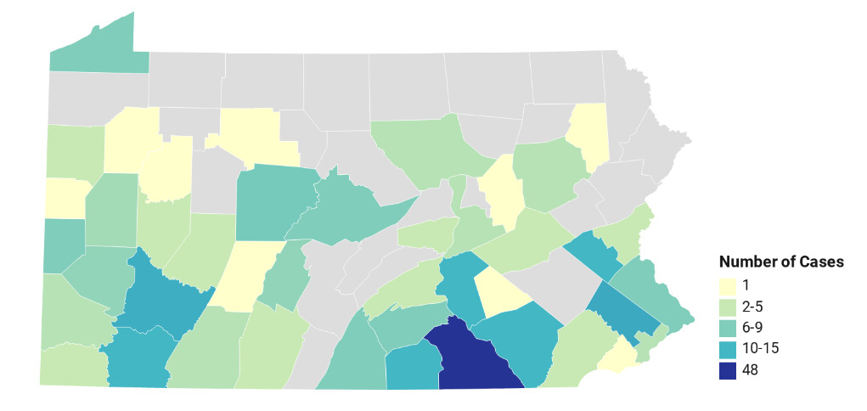[](http://www.nmslabs.com/)[](http://www.cfsre.org/)[](http://www.npsdiscovery.org/)

**June 2020**

**Prevalence of NPS Benzodiazepines in Impaired Driving and Death Investigation Casework in Pennsylvania (USA)**

Cases by County in Pennsylvania

**NPS Benzodiazepines (aka Designer Benzodiazepines) are   
 synthetic manufactured drugs.**



|  |  |  |  |  |
| --- | --- | --- | --- | --- |
| **DUID** |  |  | Postmortem |  |
| **Year** | **New Cases** | **Incidence (per 1,000 persons)\*** | **Deaths** | **Mortality (per 1,000 persons)\*** |
| **2017** | **23** | **0.0018** | **8** | **0.00055** |
| **2018** | **42** | **0.00328** | **15** | **0.00117** |
| **2019** | **99** | **0.00773** | **17** | **0.00133** |

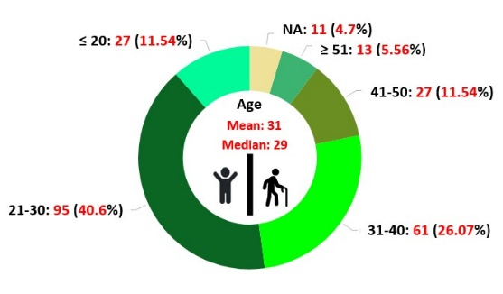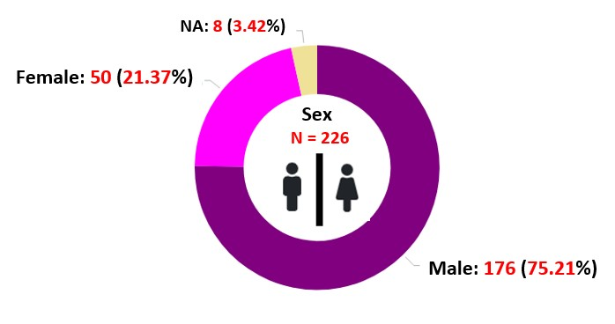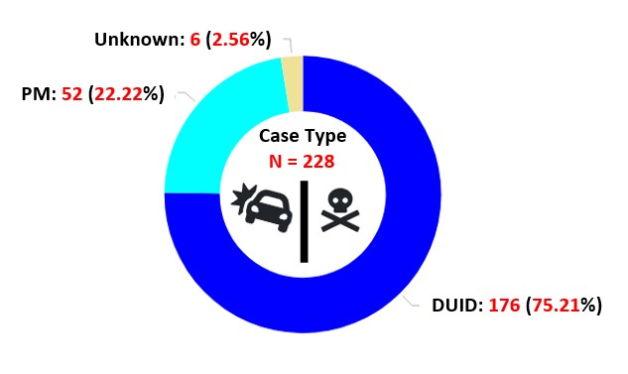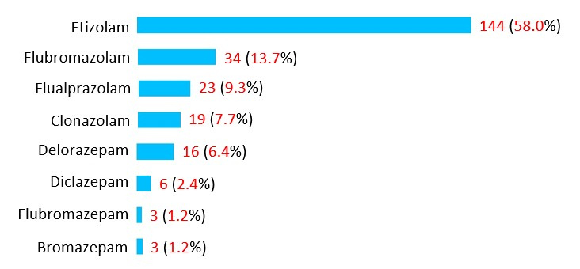   
  
  
  
  
  
  
   
  
  
  
  
  
  
  
  
  
  
  
  
  
  
  
  
  
  
  
  
  
  
  
  
   
  
  
  
  
 *Census statistics for Pennsylvania used in calculation  
  
  
  
  
  
  
  
  
  
  
  
  
  
  
  
  
  
  
  
  
  
  
  
  
 Limitations: Data is based on samples received at NMS Labs, and may not be fully representative of the   
 statistics for Pennsylvania.  
 **Acknowledgements:** This report was prepared by Alex J. Krotulski, PhD; Tiffany Chan, MPH; Donna M. Papsun, MS, D-ABFT; and Barry K. Logan, PhD, F-ABFT.   
 Data were provided by NMS Labs for analysis and graphic depiction at CFSRE.

Case Type, Gender, and Age

**Common symptoms of NPS:**  
   **Strong Sedation Amnesia  
  
Additional effects:**  
 - Loss of coordination (Ataxia)  
 - Minor Respiratory Distress  
 - Drowsiness  
 - Dizziness  
 - Blurred Vision  
 - Slurred Speech  
 - Can Result in Death

Benzodiazepine Varieties and Frequencies

Measuring the Occurrence of DUID and Postmortem Cases

Declaration: Geographical distribution may be limited by location of submitting agencies and not necessarily representative of all jurisdictions.

**References and Related Articles:**

• Logan, BK. et al. (2017) [Reports of Adverse Events Associated With Use of Novel Psychoactive Substances, 2013-2016: A Review](https://academic.oup.com/jat/article/41/7/573/3778265). *J Anal Toxicol.* 41(7): 573-610

• [Flualprazolam: Potent Benzodiazepine Identified Among Death & Impaired Driving Cases in the U.S.](https://www.npsdiscovery.org/wp-content/uploads/2019/12/Public-Alert_Flualprazolam_NPS-Discovery_120519.pdf) Public Alert, *NPS Discovery*, December 2019.